P-Kerb
Image:
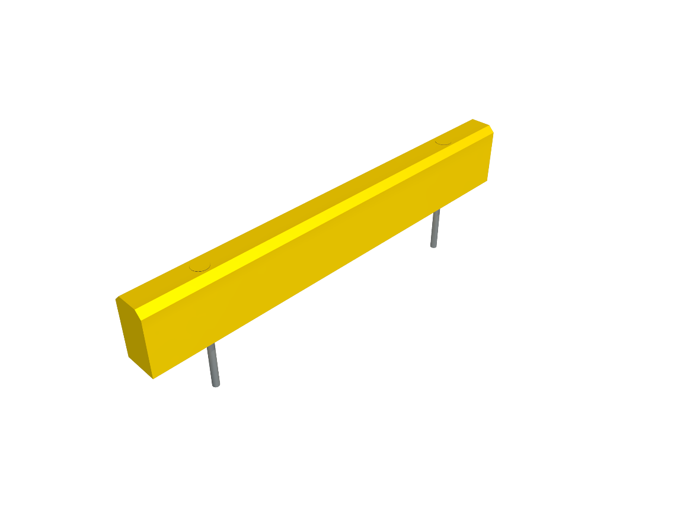

Description: High-performance polymer protection kerb system designed for the protection of people, equipment, and assets.

Features and Benefits:
- High-Performance protection technology designed to safety absorb impacts.
- Available in various lengths, diameters and heights.
- Unique “Hidden” steel threaded rod anchoring system.
- Hygienic and easy to clean and maintain.
- Tested to BS EN 1186-2:2002 and BS EN 1186-3:2002 for food contact.
- Suitable for temperatures between -100°C to +80°C
- Zero exposed steel or risk of exposed corrosion.
- High resistance against acids, alkali, and solvents.
- Typically 40% recycled polymer content.
- 100% recyclable at end-of-life.
- Tested to BS EN ISO 4892-2:2014 for UV Resistance – Zero Discoloration
- Bespoke branding capability.
- See Polybar product brochure for mechanical and impact resistance performance.

Technical Specification:
Dimensions (mm) |  |  |  |  | Drilling (mm)
Diameter | Length | No. Bases | Height | Rod Ø | Drill Ø | Depth
80 | 500 | 2 | 150 | 16 | 38 | 150
80 | 1000 | 2 | 150 | 16 | 38 | 150
80 | 1500 | 3 | 150 | 16 | 38 | 150
80 | 2000 | 3 | 150 | 16 | 38 | 150

Colours:
- Yellow RAL1021– standard
- Black RAL 9004
- Other non-standard colours available – Contact Polybar for further information.
Unique high-performance polymer technology testing:
- Density g/m³ ISO 1183: 0.95
- Yield Stress N/mm² DIN EN ESE 527: 28
- Elongation yield % DIN EN ISO 527: +8
- Elongation al break %: 300
- Tensile E Modulus MPa DIN EN ISO 527: 850
- Impact strength KJ/m² DIN EN ISO 179: without break
- Notched Impact Strength KJ/m² DIN EN ISO 179: 50
- Ball identification hardness N/mm² DIN EN ISO 2039-1: 45
- Shore Hardness D ISO 868: 66
- Average Thermal Coefficient of elongation K⁻¹ DIN 53752: 1’8. 10⁻⁴
- Thermal Conductivity W/m*K DIN 52612: 0.38
- Dielectric Strength KV/mm VDE 0303-21: 44
- Surface resistance Ohm DIN IEC 167: 10¹⁴
- Temperature Range °C -100 up to +80
- Physiologically acceptable: yes
- Welding: yes
- Hot Forming: possible

Uniclass 2015: Ss_25_16_94_65 Protective rail systems
Literature: Polybar Product Brochure & Product Datasheets can be found on: www.polybargroup.com
Revit files can be found on: www.polybargroup.com

